**TITLE: ASSESESMENT ON THE USE OF SOCIAL NETWORKING TOOLS IN ACCESSING INFORMATION BY UNIVERSITY STUDENTS IN TANZANIA: A CASE OF MBEYA UNIVERSITY OF SCIENCE AND TECHNOLOGY**

**NAME OF STUDENT: FATHIYA SEIF MOHAMMED**

**A RESEARCH / PROJECT SUBMITTED IN PARTIAL FULFILMENT OF THE REQUIREMENTS FOR THE BACHELOR OF SCIENCE IN INFORMATION AND COMMUNICATION TECHNOLOGY OF MBEYA UNIVERSITY OF SCIENCE AND TECHNOLOGY MBEYA, TANZANIA**

**2025**

**MBEYA UNIVERSITY OF SCIENCE AND TECHNOLOGY**



**COLLEGE OF INFORMATION AND COMMUNICATION TECHNOLOGY**

**DEPARTIMENT OF INFORMATION SYSTEMS AND TECHNOLOGY**

**NAME OF PROGRAMME BACHELOR OF SCIENCE IN INFORMATION AND COMMUNICATION TECHNOLOGY**

**TITLE: DEVELOPMENT OF SMART MENU FOOD ORDERING IN RESTAURANT AND HOTELS USING QR CODES: A CASE OF MBEYA UNIVERSITY OF SCIENCE AND TECHNOLOGY**

**NAME OF STUDENT: FATHIYA SEIF MOHAMMED**

**REG NO:22101133370095**

**A RESEARCH PROPOSAL SUBMITTED IN PARTIAL FULFILMENT OF THE REQUIREMENTS FOR THE DEGREE OF MBEYA UNIVERSITY OF SCIENCE AND TECHNOLOGY**

**MBEYA, TANZANIA**

**2025**

Table of Contents

CERTIFICATION i

ACKNOWLEDGEMENT ii

DECLARATION iii

CHAPTER ONE: INTRODUCTION 1

1.1 BACKGROUND 1

1.2 PROBLEM STATEMENT 2

1.3OBJECTIVES 3

1.3.1 Main Objective: 3

1.4 Project Significance 3

1.5 Project Scope 6

CHAPTER TWO: LITERATURE REVIEW 8

2.1 Related Works 8

2.1.1Historical Background 8

2.2 Similarities to Existing Systems 9

2.3Identified Gaps and Proposed Enhancements 10

2.4What am going to add 11

CHAPTER THREE: METHODOLOGY 12

3.1 Research Approach 12

3.1.1 Technology Stack 12

3.1.2 Materials and Methods 12

3.1.3 Data Collection Methods: 13

3.1.4 Data Analysis Methods: 13

3.1.5 System Design 14

Appendix I: Budget Breakdown 15

Appendix II: Development Time Line (GANTT CHART) 16

REFERENCES 17

# CERTIFICATION

I, Mr. David Mwakifuna, certify that I have supervised and recommend for acceptance by Mbeya University of Science and Technology this project proposal titled “Development of Smart Menu Food Ordering in Restaurant and Hotels using QR codes”, submitted by Fathiya Seif Mohammed (Reg No 22101133370095) in partial fulfillment of the requirements for the Bachelor of Science in Information and Communication Technology

Supervisor’s Name: Mr. David Mwakifuna

Signature:

Date:6/3/2025

# ACKNOWLEDGEMENT

I beholden to encompass my sincere deepest gratefulness’s to God for giving me the guidance, health, thought and strength throughout the time for this project, I would like to express my sincere gratitude to my supervisor, D. Mwakifuna, for their guidance and support throughout this project, as well as my project coordinator Mr. Magemo, they gave me moral support and guided me in different matters regarding my project accomplishment. I would also like to express my gratitude to all staff of Information system and technology department at Mbeya University of Science and Technology for their suggestions during my presentations I also extend my thanks to my peers, friends, and family for their encouragement and assistance. Special appreciation goes to the restaurant owners and users who provided valuable insights and feedback during the research.

# DECLARATION

I, Fathiya Seif Mohammed (Reg No 22101133370095), declare that this project proposal is my original work and has not been submitted to any other institution for a similar award.

Student’s Name: Fathiya Seif Mohammed

Signature:

Date:6/3/2025

# 

# 

# CHAPTER ONE: INTRODUCTION

## 1.1 BACKGROUND

Menus plays an integral role in the restaurant industry as they serve as a communication tool between the kitchen and the customer. Though menu is found in most of the restaurant worldwide but the mode, type and method differ from restaurant-to-restaurant base on location, type of the targeted customers and the standard of the restaurant. These include the human menu; which makes use of verbal communication between the customer and the waiter in which the waiter verbally tells the customer the available food and the customer make his choice verbally also without any documentation. The paper menu; this type of menu, uses the pen, the paper printed with the available food and the customer make use of the pen to make his or her choice. Lastly the digital/electronic menu; this is the most accurate and efficient type which deploys information and communication technology facilities to perform its functions.

Businesses in hospitality industry based on food services have grown significantly worldwide. In the last few years where many restaurants have opted to offering various types of menus for the customer, this has increased the competition in the hospitality industry. The Restaurants must provide the best services and maintain strong relationships with customers to survive in a competitive market. One way to address this challenge is through the introduction of technology in the industry. Customers can now select food from a restaurant's menu by scanning a QR code on a device provided at their table, allowing orders to be sent directly to the kitchen via a network

## 

## 1.2 PROBLEM STATEMENT

#### Many restaurants still rely on printed menus and manual order-taking, leading to inefficiencies, delays, and miscommunication. Paper-based menus often include many food options that may not be available, leading to customer frustration. Additionally, traditional menus do not accommodate disabled individuals, such as those who may have difficulty speaking or communicating with waiters. This project aims to solve these issues by implementing a QR code-based smart menu system.Challenges with Traditional Menu Systems

**Menu Updates and Availability Issues**

Printed menus become outdated quickly, especially when certain food items are unavailable due to supply shortages or seasonal changes.

Customers may order items that are no longer available, leading to frustration and wasted time for both staff and diners.

**Order Processing Delays and Human Errors**

Waiters manually taking orders can lead to mistakes, especially during peak hours when the restaurant is busy.

Miscommunication between customers and staff, particularly in noisy environments, can result in incorrect orders being served.

**Lack of Accessibility for Disabled Individuals**

Traditional menus do not accommodate individuals with disabilities, such as those who have difficulty reading small fonts, visually impaired individuals, or those who cannot communicate verbally.

Customers who are deaf, mute, or have speech impairments may struggle to place their orders effectively.

**Time-Consuming and Labor-Intensive Process**

Customers often have to wait for waiters to bring menus, take orders, and confirm availability, increasing waiting times.

Staff must repeatedly attend to the same table for menu explanations and order modifications, leading to inefficiencies in service.

**Health and Hygiene Concerns**

Physical menus are shared between multiple customers, posing hygiene risks, especially in the post-pandemic era where minimizing physical contact is encouraged.

Proposed Solution: QR Code-Based Smart Menu System

To address these challenges, this project proposes the development of a QR code-based smart menu system.

## 1.3OBJECTIVES

## 1.3.1 Main Objective:

To develop a smart menu food ordering system using QR codes for restaurants and hotels.

**1.3.2 Specific Objectives:**

1. To create QR codes that link to the restaurant's digital menu.
2. To design a user-friendly interface for easy usability.
3. To create a database for menu update items and prices

## ****1.4 Project Significance****

**Enhanced Customer Experience**

A seamless dining experience is critical to customer satisfaction. This system ensures an interactive, convenient, and personalized experience for diners.

**Interactive and Engaging Menu System**

Customers can scan a QR code placed on tables to access the digital menu instantly, eliminating the need to wait for a printed menu.

The system displays high-quality images of dishes, ingredient lists, and customer reviews, making ordering more engaging and informed.

**Convenience and Self-Service**

Customers can place orders directly from their smartphones without calling a waiter, making the process faster and smoother.

Special requests, such as extra toppings, no onions, or spice levels, can be selected easily through the digital interface.

**Faster Order Processing and Reduced Waiting Time**

Orders are sent directly to the kitchen, reducing wait time for taking orders manually.

This results in faster table turnover rates, allowing restaurants to serve more customers in a shorter period.

**Menu Updates**

Unlike printed menus, the digital menu can be updated in real-time to show food availability.

Customers are notified if an item is sold out, reducing frustration from ordering unavailable dishes.

**Operational Efficiency**

Restaurants and hotels can optimize their workflow with this system, leading to improved service delivery and smoother kitchen operations.

**Reduced Order-Taking Errors**

Waiters manually taking orders can lead to miscommunication, especially in noisy environments.

This system automates order placement, ensuring that what the customer selects is accurately transmitted to the kitchen.

**Workflow for Wait staff and Kitchen Staff**

Since orders are sent directly to the kitchen, wait staff can focus on customer service rather than manually taking orders.

Kitchen staff receive clear and accurate orders, reducing confusion and improving preparation time.

**Optimized Table Management**

Restaurants can track which tables have placed orders and their status, allowing for better time management.

Staff can identify high-demand items based on ordering trends and adjust inventory accordingly.

**Cost Savings**

The smart menu system significantly reduces operational costs in multiple areas, leading to increased profitability.

**Eliminates Printing Costs**

Traditional menus require frequent reprinting due to price changes, new menu items, or menu wear and tear.

A digital menu can be updated instantly at no cost, saving money on printing and design fees.

**Reduces Labor Costs**

Fewer wait staff are needed since customers can place orders independently through their mobile devices.

Restaurants can allocate labor more efficiently, focusing on customer service rather than repetitive tasks.

**Minimizes Food Wastage**

Since the system provides real-time menu updates, customers won’t order unavailable items, preventing kitchen confusion and waste.

Restaurants can also track which dishes are frequently ordered or ignored, helping with better inventory management.

**Increased Accessibility**

The QR code-based smart menu system ensures equal access for all customers, including individuals with disabilities.

Enhances Accessibility for Customers with Speech or Hearing Impairments

Customers who are deaf or mute may struggle to communicate with wait staff.

With the self-ordering system, they can place orders without verbal interaction, ensuring an independent and smooth experience.

**Multi-Language Support**

Tourists and non-native speakers can select their preferred language, ensuring they understand the menu without confusion.

This feature is beneficial in hotels and tourist-heavy locations, where multiple languages are spoken.

## ****1.5 Project Scope****

This project aims to **design and develop a QR code-based smart menu system** that enhances the ordering process in restaurants and hotels. The system will allow **customers to scan a QR code, browse a digital menu, place orders, and track their order status**. Additionally, the system will include an **admin panel** for restaurant owners to manage menu items, prices, and order statuses efficiently.

The scope of this project covers **both customer-facing features and backend management functionalities**, ensuring a seamless experience for both diners and restaurant staff. Below is a detailed breakdown of the project's scope.

Customer Features

These features are designed to improve the dining experience by making menu access, ordering, and tracking more efficient.

QR Code-Based Menu Access

Customers can scan a QR code placed on their table using their smartphone camera.

The QR code redirects them to a mobile-friendly digital menu without requiring an app download.

Admin Panel (Restaurant Management System)

The admin panel is designed for restaurant owners and staff to manage menu items, orders, and customer requests efficiently.

Menu Management

Restaurant owners can add, remove, or update menu items, including descriptions, images, and prices.

The system supports real-time availability updates, ensuring customers see only what’s in stock.

# 

# ****CHAPTER TWO: LITERATURE REVIEW****

## ****2.1 Related Works****

## 2.1.1Historical Background

The evolution of digital menu systems has been shaped by technological advancements and changing consumer behaviors, especially in recent years. Many restaurants have transitioned from traditional paper menus to digital and QR code-based solutions to improve service efficiency, reduce costs, and enhance customer experience.

Recent Developments in Digital Menu Systems (2020–2024)

2020–2021: The Impact of COVID-19 on Restaurant Digitalization

The COVID-19 pandemic was a major turning point for digital menu systems worldwide. During this period, many restaurants shifted from physical menus to QR code-based menus to reduce physical contact and follow health regulations.

Key Trends Observed:  
Widespread Adoption of QR Code Menus – Many restaurants started replacing paper menus with QR code-based menus to limit virus transmission.

Basic Digital Menus (PDF-based Menus) – Most restaurants used simple PDF menus accessed via QR codes, but these were not interactive and lacked real-time updates.  
 Customer Resistance to Digital Menus – Some customers preferred printed menus due to unfamiliarity with digital systems, leading to a slow transition in certain regions.

2022–2023: Growth of Interactive Digital Menu Solutions

As businesses adapted to new customer expectations, restaurants began improving their QR-based menu systems by making them more interactive and user-friendly.

Key Trends Observed:  
 Development of Mobile-Friendly Digital Menus – Restaurants moved from static PDF menus to dynamic, interactive web-based menus.  
 Integration with Online Ordering & Payments – Some advanced systems allowed direct ordering and payment from the digital menu.  
Challenges with Accessibility Features – Many systems did not support disabled users, making it difficult for visually impaired or non-verbal individuals to use the service.

2024: The Rise of Smart Restaurant Technologies

By 2024, several innovations in restaurant menu technology had been introduced. However, many existing solutions still had limitations related to accessibility, real-time updates, and user engagement.

## ****2.2**** ****Similarities to Existing Systems****

Several restaurants and hotels use mobile apps and web-based menus, but most require customers to download applications. The proposed system eliminates this need by using a direct web-based approach accessible via QR codes.

**Web-Based Menu and Online Order Processing**

**Similar to Other Digital Solutions:**

Some existing restaurant ordering systems use **web-based platforms** where customers can **view the menu and place orders online.**Web-based menus provide a **mobile-friendly interface** for users to interact with the system.

**How My Project Compares:** Unlike many restaurant ordering systems that require **app downloads**, my system **is purely web-based** and accessible through **any mobile device with an internet connection.**My project **eliminates the need for customers to install any applications**, reducing **barriers to usage.**

## ****2.3****Identified Gaps and Proposed Enhancements

Existing digital menu solutions lack accessibility features and real-time order tracking. This project introduces:

**Slow Order Completion Process**

Many restaurants still rely on waiters to take and confirm orders, leading to delays during peak hours.

Some digital menus do not have direct integration with the kitchen, requiring manual order entry by staff.

Miscommunication between customers, waiters, and kitchen staff results in incorrect or missing orders. Customers often do not receive updates on their order status.

**Lack of Automatic Menu Updates and Availability Management**

If a dish is sold out, customers may still order it, leading to cancelled orders and frustration. Waiters must manually inform customers when items are unavailable, causing service delays.

Poor Customer Satisfaction Due to Order Errors and Service Delays Customers often receive wrong or incomplete orders due to human error in taking orders manually.

Waiters may misinterpret customer requests, leading to incorrect food items being served.

Many digital ordering systems do not provide estimated wait times, leaving customers uncertain about their food arrival.

Limited Accessibility for Disabled Customers (Dumb and Deaf Impaired)

Many digital menus do not support accessibility features, making it difficult for disabled individuals to place orders.

Deaf and mute customers may struggle to communicate with waiters.

## 

## 2.4What am going to add

Considering the disabled people such as dumb and deaf

Touch-Based Navigation: The interface will be optimized with large, easy-to-press buttons to help individuals with mobility impairments navigate the menu effortlessly.

Ability to update the menu items and price **Modify Menu Items:** Add, remove, or update food items as availability changes.

**Adjust Prices:** Restaurant owners can update prices, ensuring that customers always see the latest prices without requiring new printed menus. Keeping records of the customers and what they ordered

Data Analytics**:** Restaurant owners can analyze customer preferences, peak ordering times, and most popular dishes to improve menu offerings and service efficiency.

Customer Feedback Collection**:** The system will allow customers to leave reviews and ratings, helping restaurants refine their menu and services.

# 

# 

# CHAPTER THREE: METHODOLOGY

## 3.1 **Research Approach**

This studyfocusing on the **practical implementation** of a **QR code-based smart menu system.** The goal is to develop a **functional and user-friendly system** that improves restaurant and hotel ordering processes by enhancing **efficiency, accessibility, and accuracy**.

To ensure flexibility and continuous improvement, the system will be developed using the **Agile methodology**, allowing for **incremental updates, user feedback integration, and iterative development cycles**. Agile ensures that:

Features are built and tested in **small, manageable phases** (sprints).  
 Regular feedback from **restaurant owners, customers, and developers** is incorporated.  
**Rapid adjustments** can be made to meet user expectations and system requirements.

## ****3.1.1 Technology Stack****

The system will be developed using **Python and PHP** to ensure compatibility **with web-based applications** and **database management systems**.  
 **Backend:** Python (Django) for **order processing, user authentication, and QR code generation.  
Frontend:** PHP, HTML, CSS, and JavaScript for the **web-based menu and admin panel.**  
**Database:** MySQL/PostgreSQL for **storing menu items, orders, user accounts, and transactions.**

## **3.1.2 Materials and Methods**

Hardware Requirements:

Web server (e.g., Apache or Nginx)

Database server (e.g., MySQL or PostgreSQL)

Client devices (Smartphones, Tablets, Computers)

QR Code scanner (Camera-enabled smartphones)

Software Requirements:

Programming languages: Python (for backend logic) and PHP (for web development)

Web frameworks: Django (Python) or Laravel (PHP)

Database management system: MySQL/PostgreSQL

Frontend technologies: HTML, CSS, JavaScript

QR code generation API or library (e.g., Python QR Code Library, Google QR Code API)

## 3.1.3 Data Collection Methods:

To ensure the efficiency of the system, data will be collected through:

Surveys and Interviews: Conducted with restaurant owners and customers to determine key requirements.

Observation: Studying existing manual ordering processes to identify bottlenecks.

System Logs and Analytics: Gathering data from initial system trials for optimization.

## 3.1.4 Data Analysis Methods:

Statistical Analysis: Evaluating user engagement and order processing time.Database Query Analysis: Reviewing query execution times and response rates to ensure efficiency.

Usability Testing: Conducting A/B testing for interface improvements.

3.1.5 System Design

The system will follow a three-tier architecture:

1. **Presentation Layer (Frontend):**
   * Designed using HTML, CSS, and JavaScript.
   * User-friendly interface for menu browsing and order placement.
2. **Business Logic Layer (Backend):**
   * Implemented using Python (Django) or PHP (Laravel).
   * Handles menu management, order processing, and user authentication.
3. **Data Layer (Database):** MySQL/PostgreSQL database to store menu items, orders, customer records, and transaction details.

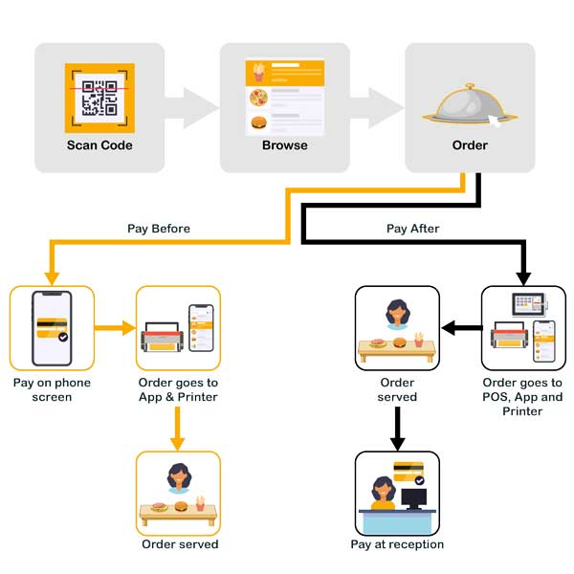

Figure 1 semantic diagram

APPENDICES

## Appendix I: Budget Breakdown

To accomplishing the project, the requirement and all other expenditures are expected to be as follows in the table below:

|  |  |  |
| --- | --- | --- |
| Item | Estimated Cost (TZS) | Description |
| **QR Code Generator** | 100,000 TZS | API or tool for dynamic QR code generation. |
| **Software Development Tools** | 50,000 TZS | Software, IDEs, and libraries for coding. |
| **Database Management System (MySQL/PostgreSQL)** | 50,000 TZS | Storing menu items, orders, and customer records. |
| **Testing & Debugging** | 50,000 TZS | Ensuring system functionality before launch. |
| **Deployment & Maintenance** | 50,000 TZS | Server setup, updates, and ongoing system support. |
| **Marketing & Training** | 50,000 TZS | Promotion and staff training for system usage. |
| Total Estimated Cost | 350,000 TZS | Overall cost for the project implementation. |

# 

# 

# Appendix II: Development Time Line (GANTT CHART)

**The bellow Gantt chart shows the timeline of the project proposal.**

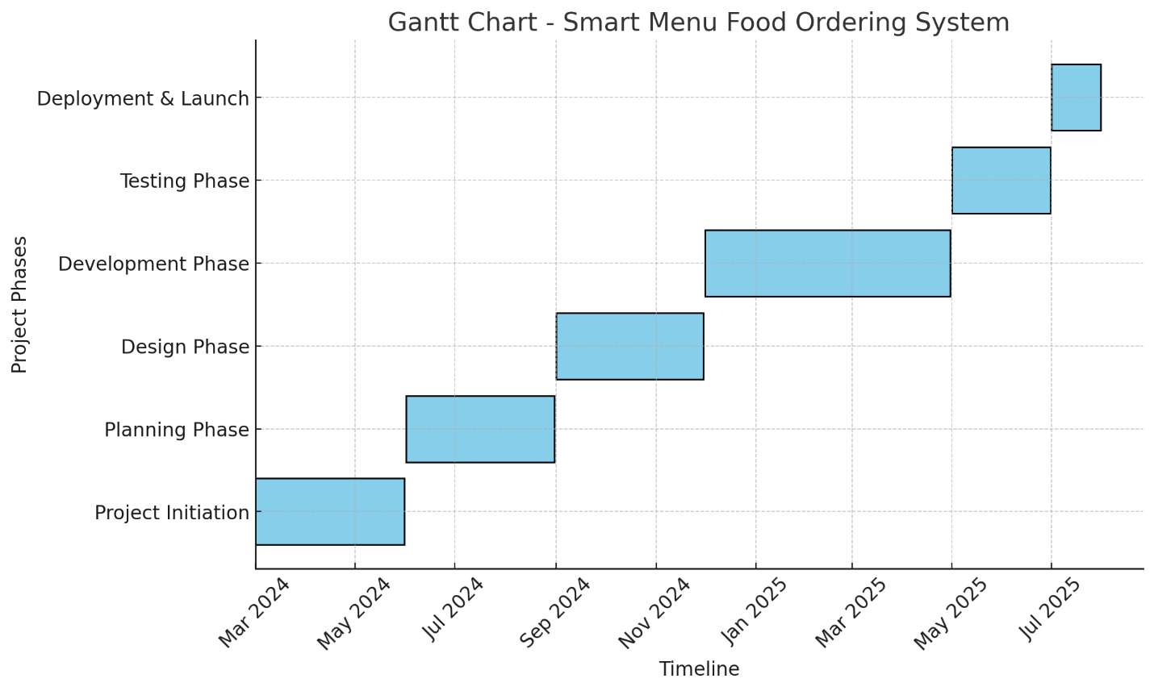

Figure 2 Gantt chart

# 

# REFERENCES

Sanjukta Saha, Dr.A. K. Santra, “Restaurant Rating Based on Textual Feedback”, IEEE, 2017.

[14] Mr. RuturajRaghunath Chava, Mr. Surajkumar Ravi Kurale, "APPLICATION OF QR CODE TECHNOLOGY TO AUTOMATE ORDERING SYSTEM IN MOVIE THEATERS", international journal of advance research in science and engineering, volume no. 07, 2018.

KARTIK PATIL, N.V. KAREKAR, "Restaurant Automation System Using QR Codes", IRE Journals, Volume 2, 2019.

Pragati Singh, Nimesh Tembhekar, Kunjal Gurve, Prof. Mrunmayee Rahate, "Smart Food Ordering System for Restaurant", international research journal of engineering and technology (irjet), volume: 07, 2020

Kunal Gupta, Stuti Saxena., 2015, “Design and Implementation of Wireless Menu Card”.

Ni Hao, Ruan Ruolin, Yao Huan, Wu Aixia., 2017, “An Economical Wireless Ordering System Based on Bluetooth Technology Fuzzy Logic”.

Guiling Sun, Qingqing Song., 2016, “Design of the Restaurant SelfService Ordering System Based on ZigBee Technology”.

P. Lessel, M. Bohmer, A. Kroner, A. Krriger, “User Requirements and Design Guidelines for Digital Restaurant Menus”, Oct2014

Kirri Bhandge, Tejas Shinde, Dheeraj Ingale, Neeraj Solanki, Reshma Totare, “A Proposed System for Touchpad Based Food Ordering System Using Android Application”, in International Journal of Advanced Research in Computer Science & Technology (IJARCST 2015), Vol. 3, Issue 1 (Jan. - Mar. 2015).

Nibras Othman Abdul Wahid (2014). "Improve the Performance of the Work of the Restaurant Using PC Touch Screen", in Computer Science Systems Biology